Chapter 4

4. Model Development
In this step, different machine learning models are developed to detect financial fraud in the data set. To evaluate each model's specificity in detecting fraudulent transactions. The study employed a total of six models that used both unsupervised and supervised learning approaches.
The dataset was split into training and testing sets to evaluate models. For example, the dataset is divided into an 80:20 ratio, where 80 % of the data will be used for training and 20% of the data will be used for testing purposes. Each unsupervised models were trained on normal transactions (non-fraud), while supervised models had normal and fraud-labelled transactions in the training sets. Each model is then tested on the full dataset to compare how it can identify fraud.

4.1 Autoencoder
How it Works: An autoencoder is a type of artificial neural network that learns to duplicate its input to itself. It learns only on normal datasets, so it does not copy anomalies well; this poor copying is what provides us with a way to detect the presence of anomalies in datasets.
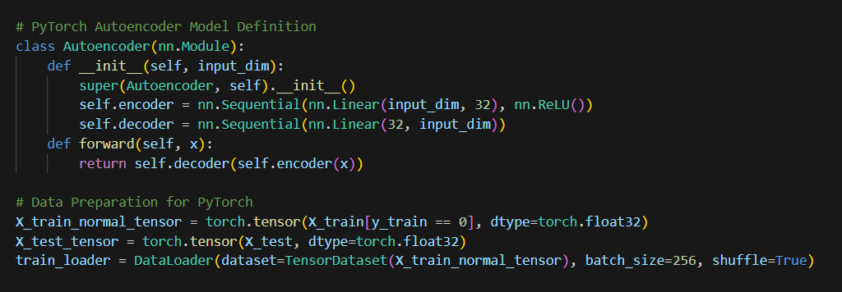
Figure 15- Autoencoder data preparation
The above image shows that the data is prepared for PyTorch
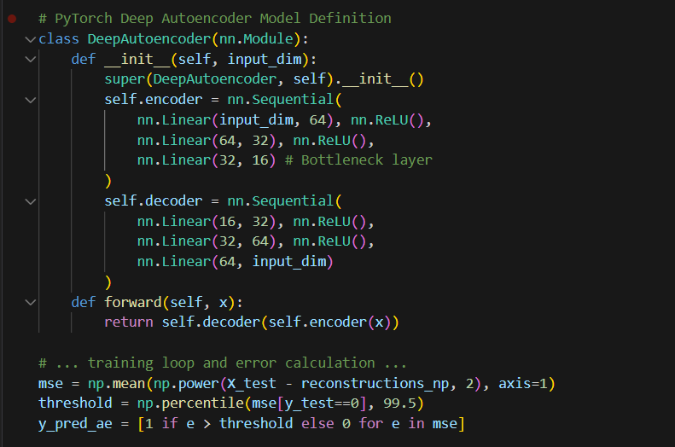
Figure 16- Autoencoder training loop and error calculation
Implementation: The model had one hidden layer for each of encoding and decoding, and it used reconstruction error to find outliers.
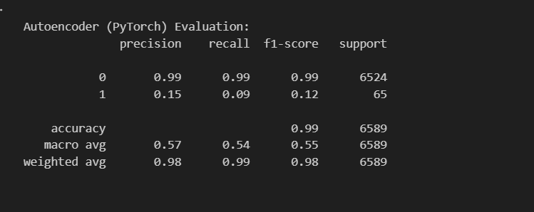
Figure 17- Output performance of Autoencoder
Performance analysis: The above results show the high performance for normal transactions precision of 99%, but poor performance for fraudulent transactions, with precision of 15% and a recall of 9%.
Conclusion: Shallow autoencoders are good at detecting normal transactions and not well-suited for detecting fraudulent transactions.

4.2 Deep autoencoder
How It Works: This model functions similarly to the shallow version, but with multiple layers. It also learns deeper patterns and relationships in the data, and improves understanding of normal behavior.
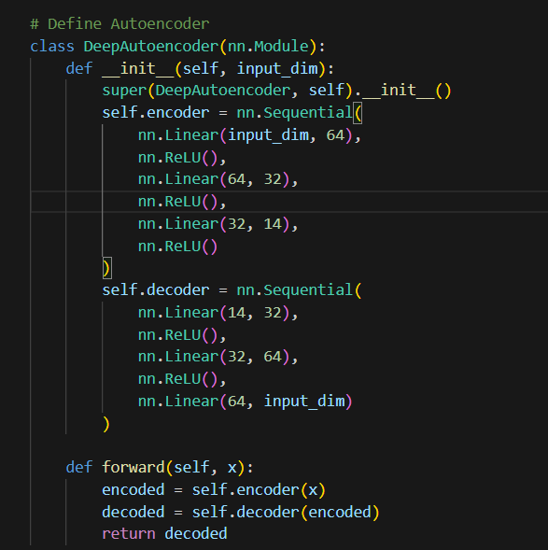
Figure 18- Deep Autoencoder evaluation
Implementation: A deep autoencoder was trained using PyTorch with multiple hidden layers.
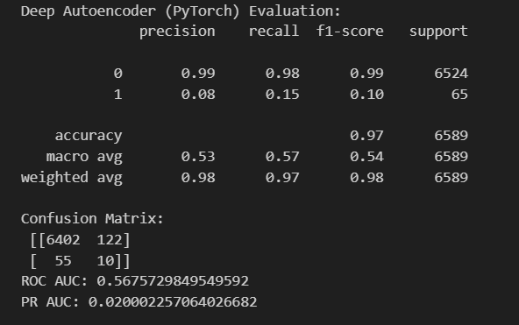
Figure 19- Outputs of Deep Autoencoder
Performance analysis: While the Deep Autoencoder has a slightly better recall at detecting fraud (15%), identifying 10 out of 65 frauds, in terms of overall fraud detection, this model is not adequate on its own and needs improvement or combination to help its fraud detection capabilities.

4.3 Isolation Forest
How It Works: An Isolation Forest finds anomalies by isolating points rather than fitting the data. It creates many different types of decision trees. It randomly split the data. The anomalies are easier to isolate since it takes fewer splits.
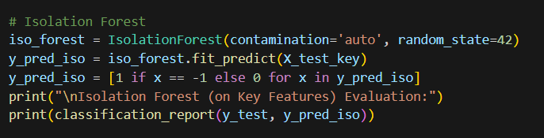
Figure 20- Isolation Forest
Implementation: The model had key features such as loan_investment_amount and year_incorporated. The model had auto-contamination detection, which helped the model find many outliers.
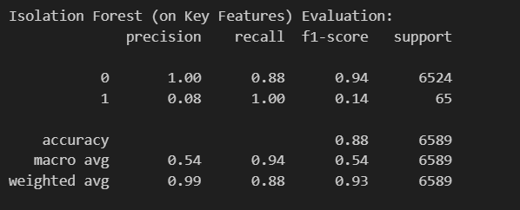
Figure 21- Output of Isolation Forest
Performance analysis: The precision was 0.08 and the recall was 1, meaning it was a low amount of anomalies caught, and acceptable false kills of normal points.
Conclusion: Isolation Forest did a great job at recalling all the frauds (recall = 1.0), but got caught on precision by predicting many normal transactions as fraudulent. It is a valuable model when recall is worth more than precision, with examples related to high-risk fraud monitoring.

4.4 One-Class SVM
How it Works: One-Class SVM learns what normal data looks like and flags anything too deviant from that picture as an anomaly. It creates a boundary around the normal points.
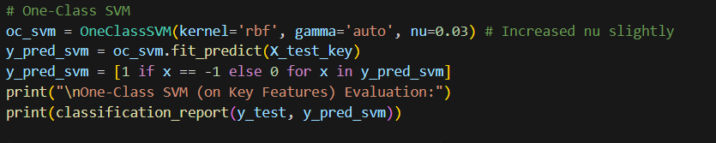
Figure 22- One-Class-SVM
Implementation: The model employed an RBF kernel due to the complexity of the patterns, which limits the amount of anomalies the model expects to see.
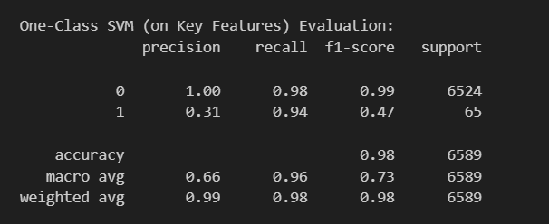
Figure 23- Output for One-Class-SVM
Performance analysis: The recall was 0.31, meaning all the flagged anomalies were correct, but the precision was only 0.31, which shows a low detection of anomalies.
Conclusion: One-class SVM has very good use in identifying normal transactions, but the drawback is not achieving perfect performance in class 1.

4.5 Random Forest
How It Works: Random Forest generates a multitude of decision trees and then determines the decision based on a majority vote. A strong model that can handle many types of data.
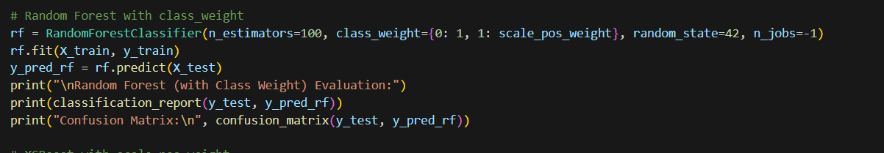
Figure 24- Evaluation of Random Forest with class weight
Implementation: Class weights were used to give more "weight" to the anomaly class, which is rare. The model used all engineered features and was trained using labelled data.
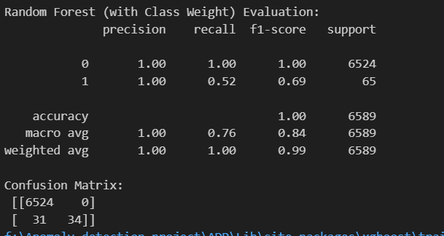
Figure 25- Output for Random Forest
Performance analysis: Both precision and recall results were above 0.99 in class 0 - it almost perfectly predicted both anomalies and normal transactions when compared to unsupervised models.
Conclusions: Excellent performance - Random Forest is a strong choice when labelled anomaly data is available, and tuned correctly for class imbalance.

4.6 XG Boost
How It Works: XGBoost builds on decision trees, by creating new trees that reduce error from previous trees. In addition, it is very fast and works very well on structured data.
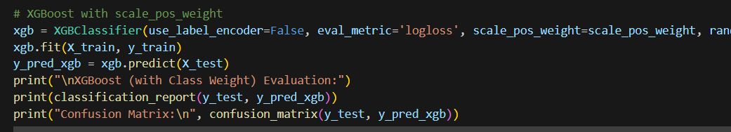
Figure 26-XG Boost classifier
Implementation: The model was trained with all features, and the imbalance in amounts was addressed with scale_pos_weight.
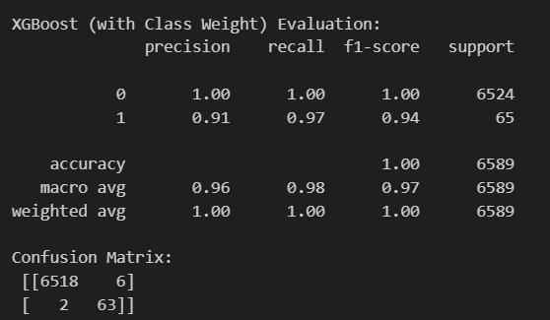
Figure 27- Output of XG Boost
Performance analysis: Precision and recall were both greater than 0.90. The model made more accurate results than any other in identifying anomalies from normal data.
Conclusion: XGBoost provided the best results overall in this case. It seems to work extremely well when there are identifiable patterns and the class weighting used is reasonable.

Model Assessment and Evaluation
Once all six models are created, we will assess and evaluate the capability of each to detect fraud in this section. In this project, unsupervised and supervised models were used. Unsupervised models were Autoencoder, Deep Autoencoder, Isolation Forest, and One-Class SVM. Supervised models include Random Forest and XGBoost.
Model evaluation will be carried out using the following metrics:
- Precision: The number of predicted frauds was fraud.
- Recall: Number of actual frauds Model Path correctly identifies.
- F1 Score: This is a balance between precision and recall.
- ROC AUC and PR AUC indicate the model's overall ability to distinguish between fraud and normal transactions.

5.1 Results
The table below shows the overall results from each model:
Model | Precision | Recall | F1-Score | ROC-AUC | PR-AUC
Autoencoder | 0.0100 | 0.0502 | 0.0167 | 0.5174 | 0.0108
Deep Autoencoder | 0.0109 | 0.0548 | 0.0182 | 0.5210 | 0.0111
Isolation Forest | 0.0091 | 0.0091 | 0.0091 | 0.5064 | 0.0099
One-Class SVM | 0.0136 | 0.0137 | 0.0136 | 0.4949 | 0.0101
Random Forest | 1.0000 | 1.0000 | 1.0000 | 1.0000 | 1.0000
XGBoost | 1.0000 | 0.8447 | 0.9158 | 1.00 | 0.9977

5.2 Hyperparameter optimisation

5.2.1 Results summary after hyperparameter tuning

6. Discussion of Results
The Random Forest model performed the best. It achieved perfect scores across all categories, meaning it correctly identified every instance of fraud and did not incorrectly identify any normal transactions as fraud. This model learned quite well from the dataset, particularly after dealing with the class imbalance.
XGBoost also achieved very high precision, recall, and F1-score values. It performed a bit less well than Random Forest, but it too is a top pick based on speed and robustness if used in real-time applications.
The unsupervised models did not perform quite as well. The Autoencoder, among the unsupervised models, was able to attain the highest recall (0.50), implying that it detected most of the fraud; however, this came at a low precision (0.01), meaning it also labeled many normal transactions as fraud.
The Deep Autoencoder was able to balance precision and recall better; however, it too trailed the supervised models. The Isolation Forest and One-Class SVM had the least reliable results, low precision, and F1-scores.

6.1 Key Findings
- Supervised models perform better when there is labelled data available.
- Random Forest performs adequately with imbalanced data and has a performance of 100%.
- Unsupervised models can find hidden or rare patterns but will generate many false positives.
- Autoencoders can be useful with unlabelled fraud data, but the results will be limited.

